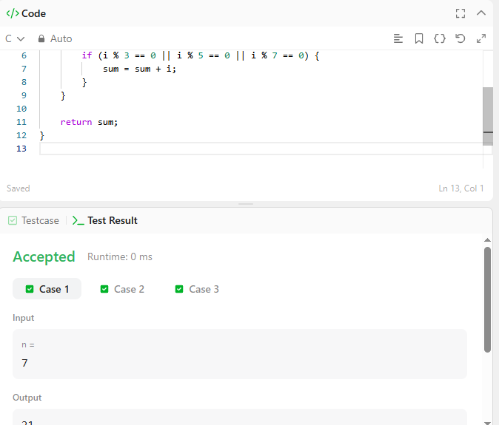

CODE -
int sumOfMultiples(int n) {
int sum = 0;

for (int i = 1; i <= n; i++) {
if (i % 3 == 0 || i % 5 == 0 || i % 7 == 0) {
sum = sum + i;
}
}

return sum;
}

LINK –
https://leetcode.com/problems/sum-multiples/

